Estimate the limit of detection of the silver analysis.

What is the Limit of detection?
It is the lowest quantity of a substance that can be distinguished from the absence of that substance (a blank value) within a stated confidence limit (generally 1%).

 | Coefficients | Standard Error | t Stat | P-value
Intercept | 0.002107 | 0.004787 | 0.440144 | 0.678209
Conc | 0.025164 | 0.000266 | 94.76047 | 2.48E-09

Intercept and Slope estimates in bold.

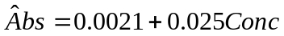

95% confidence interval for slope
Estimate ot Slope = 0.025164
Std. Error for slope = 0.000266 from table
Quantiles (given) = -2.57 for Lower
= 2.57 for Upper

Lower bound = 0.025164 + (-2.57)( 0.000266)
= 0.0243

Upper bound = 0.025164 + (2.57)( 0.000266)
= 0.0257

Confidence Interval = [0.0243, 0.0257]

N.B. Square Brackets

95% confidence interval for intercept
Estimate ot intercept = 0.002107
Std. Error for intercept = 0.004787

Confidence Interval = [-0.0102, 0.0144]

Find the silver concentration for a sample giving an absorbance
of 0.42 in a single determination

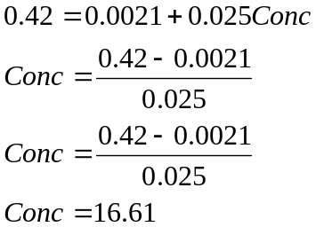

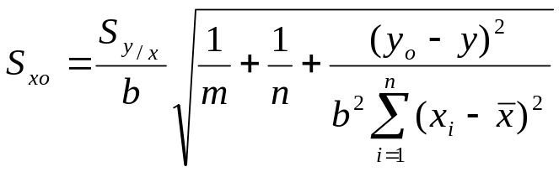

Number of test values m=1
calibration sample size n=7
slope estimate b=0.025
mean absorbance 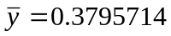
mean concentration 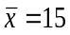
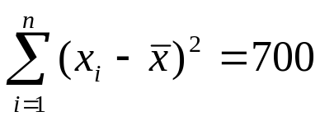

Residual Std. Error 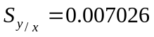
Test value y = 0.42

Std. Error = 0.2989641

Quantiles = ±2.57

Estimate = 16.61

Confidence interval = [15.84,17.38]

Response to blank signal
- estimate for absorbance when conc=0
- Intercept estimate
- y(B) = 0.0021

Response standard Error
-from data output
-S(y/x) = 0.007026

Limit of detection y(B)+3S(B) = 0.0021+3(0.007026)
Question 4a
What kind of analyses are being performed?

- unweighted linear regression fit: y = 2.92 + 1.98x
- weighted linear regression fit : y = 3.48 + 1.96x

predict x when when y=45 for both types of regression

Unweighted = 21.25
Weighted = 21.28

Question 4b
Quadratic Regression

Linear Regression
Question 5 ANOVA

Identify the factors and their levels? Are they controllable?

Factor 1) Titration methods
Level A,B,C controllable

Factor 2) Solutions
Levels 1,2,3,4 Not controllable

Factor of Primary Interest

Nuisance factor

Degrees of freedom
d.f. =cr-1
Interactions?
What are interactions?
Why not observable?

Critical value = 5.143

Critical value = 4.757

2 factor ANOVA
2 way table of continuous random variables with r rows and
c columns.
The ith row and jth column meet in the cell (i,j) that contains the random variable Xij . The expected value of that random variable is defined as E[Xij ]= μij .

Two-way analysis of variance is based on
the further assumption that the cell population means have an additive structure:
μij = μ + αi + βj .

Here μ is the overall mean, the row effects αi add to zero, and the column effects βj add to zero.

rS²_{C} , called the “Mean Between Columns Sum of Squares” is
an unbiased estimator of σ².

It is usual to call r(c − 1) S²_{C}the “Between Columns Sum
of Squares. “

It has (c − 1) degrees-of-freedom.

Given
SSTot = 0.0513 df = cr-1 = 11
SSRow = 0.0111 df = c-1 = 2
SSCol = 0.0120 df = r-1 = 3

SSTot = SSRow + SSCol + SSRes
SSRes is therefore 0.0282
df = (r-1)(c-1) = 6

ANOVA
Source of Variation | SS | df | MS | F stat | F crit
Rows | 0.0111 | 3 | 0.003697 | 0.787108 | 4.757063
Columns | 0.0120 | 2 | 0.006008 | 1.279125 | 5.143253
Error | 0.0282 | 6 | 0.004697
Total | 0.0513 | 11

